**Station 1: Play C.I.A**

**Ciphers**

Caesarean Cipher: Offsets characters in the plaintext by n (1-25) letters according to their order in the alphabet.

Example:

* Key(n) = 1
* Code = abcd
* Answer = bcde

Vigenere Cipher: Vigenere Cipher: Using a key and repeating it until it matches the length of the plaintext (e.g. LEMONLEMONLE if the key is lemon and the plaintext is twelve characters). It is then encoded using the Vigenere Square (to the right).

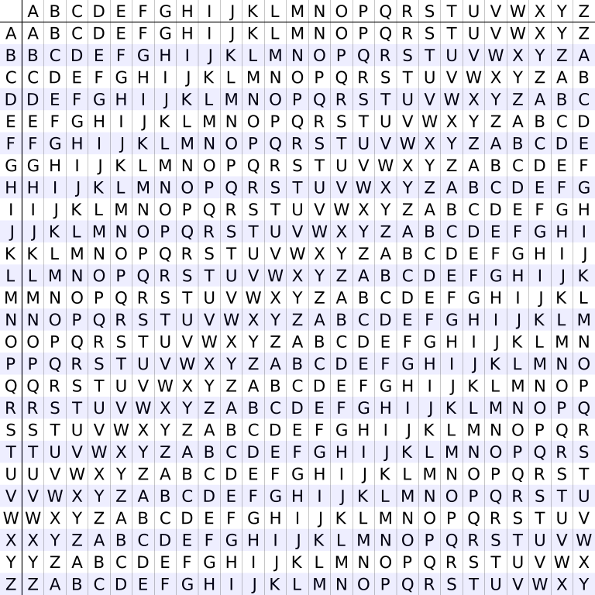Example:

* Key: pear
* Code: kmgvcirv
* Answer: vigenere

**Instructions**

* Use your new-found knowledge of ciphers to solve the following problems
* Some will use caesarean ciphers, some will use vigenere ciphers, some might be unknown
* Ignore all whitespace when deciphering (punctuation and blank spaces)
* You can ask for two hints from the station masters for each question (although the number of points awarded will be decreased by 10pts per hint)

**Questions**

**Question 1:**

1. Decode this word: VEZNUT (20pts)
2. Find a phrase related to the above decoded word to use as a key to decode this sentence:

EPHNFN TMA N JPSVMH PNMAFGUGHK FPNZ PMCNUSODTJ QUUE DQIQGMIYONY, TSIRPRP UEUVT YTGAOZIIECK KNZTQEXNIP. (30pts)

**Question 2:**

1. Decode this word: JCQTLQVOJTWKA (20pts)
2. Find a phrase related to the above decoded word to use as a key to decode this sentence: WDIJS M PERID OZH O HINSX GOITMHURG OXMRQRTO GGAQ XOCILVQV TK FMWXH AJ MFTAGOIQ-WABSWAVWR RYTQVW! (30pts)

**Question 3:**

1. Decode this word: YPDEPONTASPCD (20pts)
2. Find a phrase related to the above decoded word to use as a key to decode this sentence:

KZZL GK IDG IDWU TE YMSW LT NTOUEQFJ TFTZ TWHKJEQ DO IGW FLYV AY SH. (50pts)

**Question 4 (1 hint only):**

Decode this text: NNNWCPE?AUKONIHR (30pts)